Karthik Pradeep Hegadi

**2KE20CS032**

**Assignment 12**

*Understood. To follow the provided instructions and create the files/directory using the same name and case as provided in the task steps, please provide me with the specific names and case instructions for the files/directory you want to create.*

**Previously I did using python . In same assignment I have added using bash script at last**

**Shell scripting (optional )**

**======================================================================**

**USING PYTHON**

**======================================================================**

**Write any script to split a .gzip file into number of chunks**

1.Download a gzip file say 5gb

Here I have downloaded 173mb java package

Installed latest python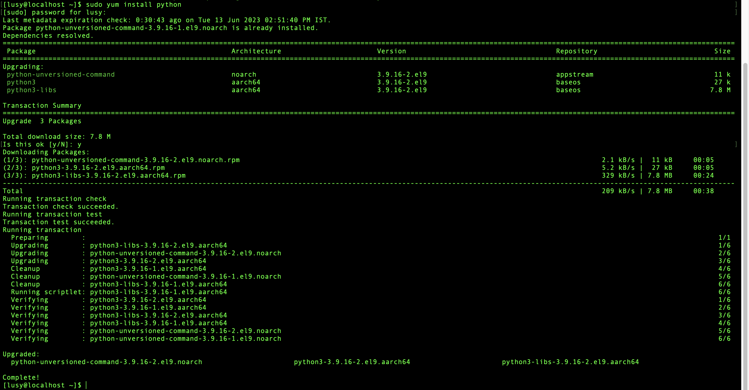

2.You need to split the 5gb into n number of chunks say chunk1, chunk2, chunk3,

chunk4 when you run the script

Here the script will ask the path of gzip file ,destination path, and finally ask for the number of chunks to createScreenshot 2023-06-13 at 3.53.39 PM.png

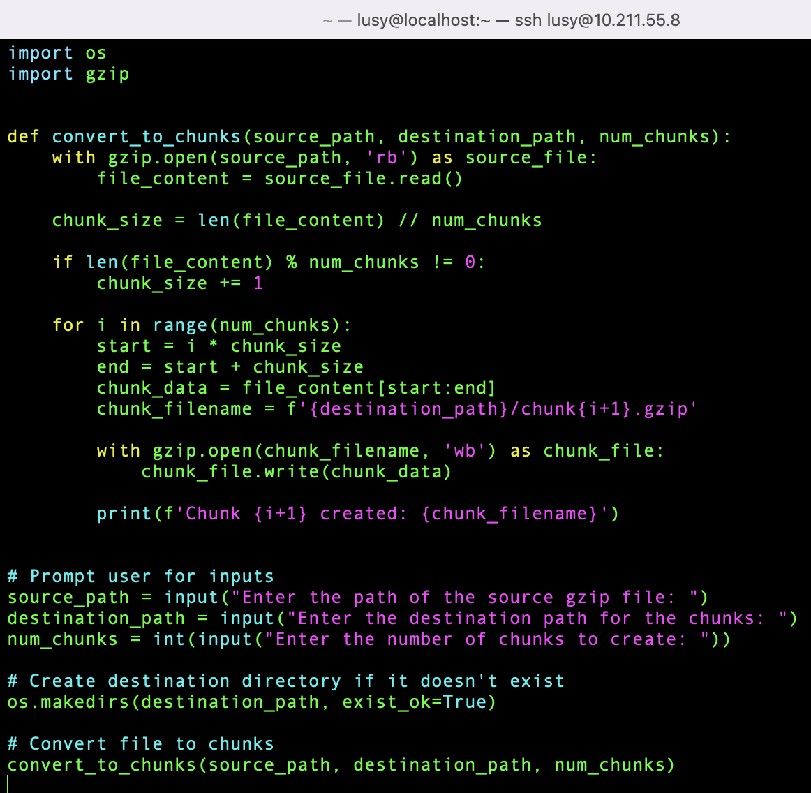

3.You can convert the chunks into gzip

Then whole hearty I will convert all those chunks in to zip file as chunk1, chunk2 etc

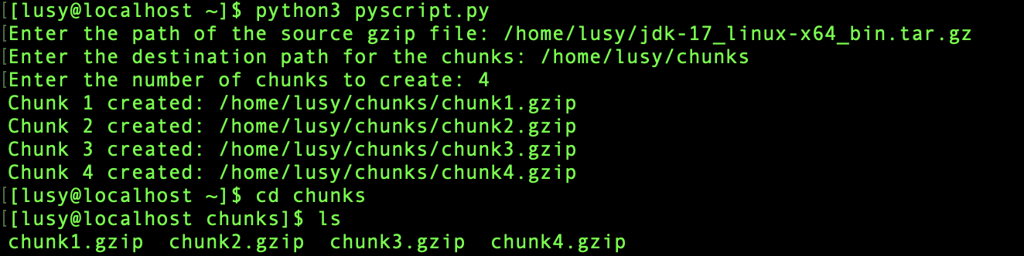**Write any script file to merge to merge all the chunks into a gzip file**

1.Once you run the script file all the chunks should be merged as a single gzip file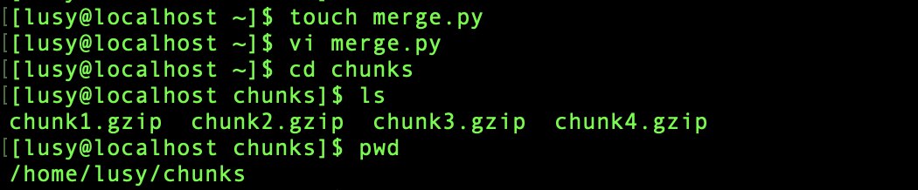

Script to merge the files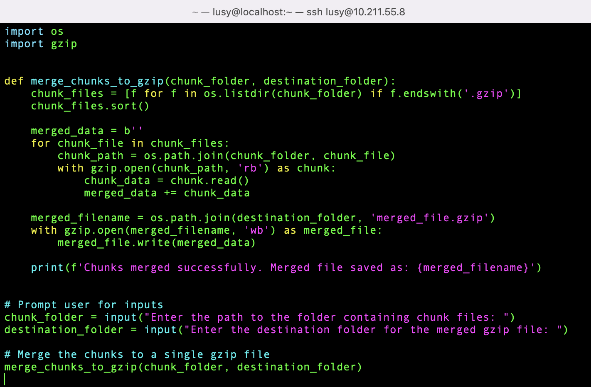

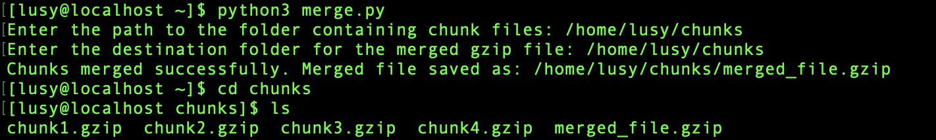

**======================================================================**

**USING BASH**

**======================================================================**

## Write any script to split a .gzip file into number of chunks

**1**.You need to split the 5gb into n number of chunks say chunk1, chunk2, 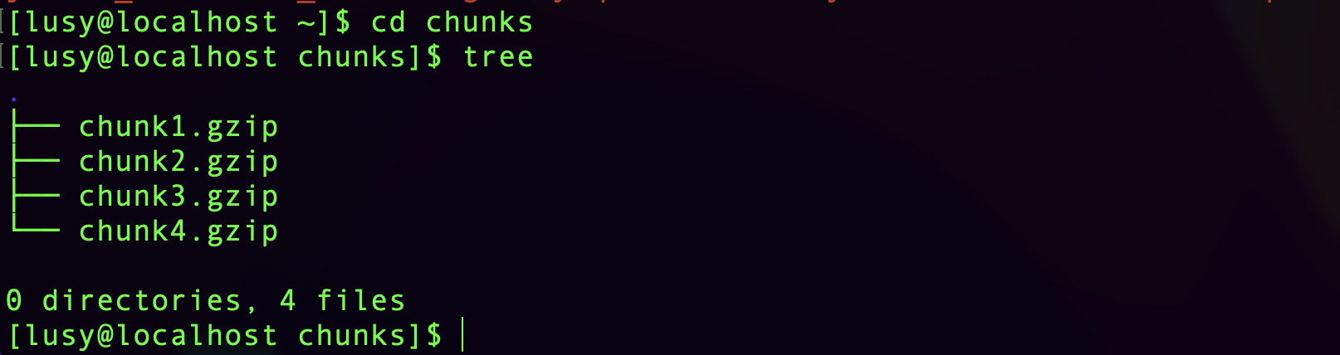chunk3,

chunk4 when you run the script

Here the script will ask the path of gzip file ,destination path, and finally ask for the number of chunks to create

3.You can convert the chunks into gzip

Then whole hearty I will convert all those chunks in to zip file as chunk1, chunk2 etc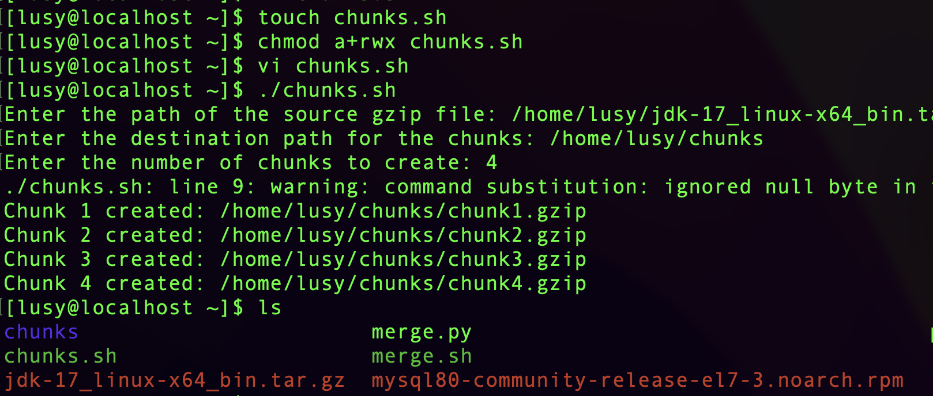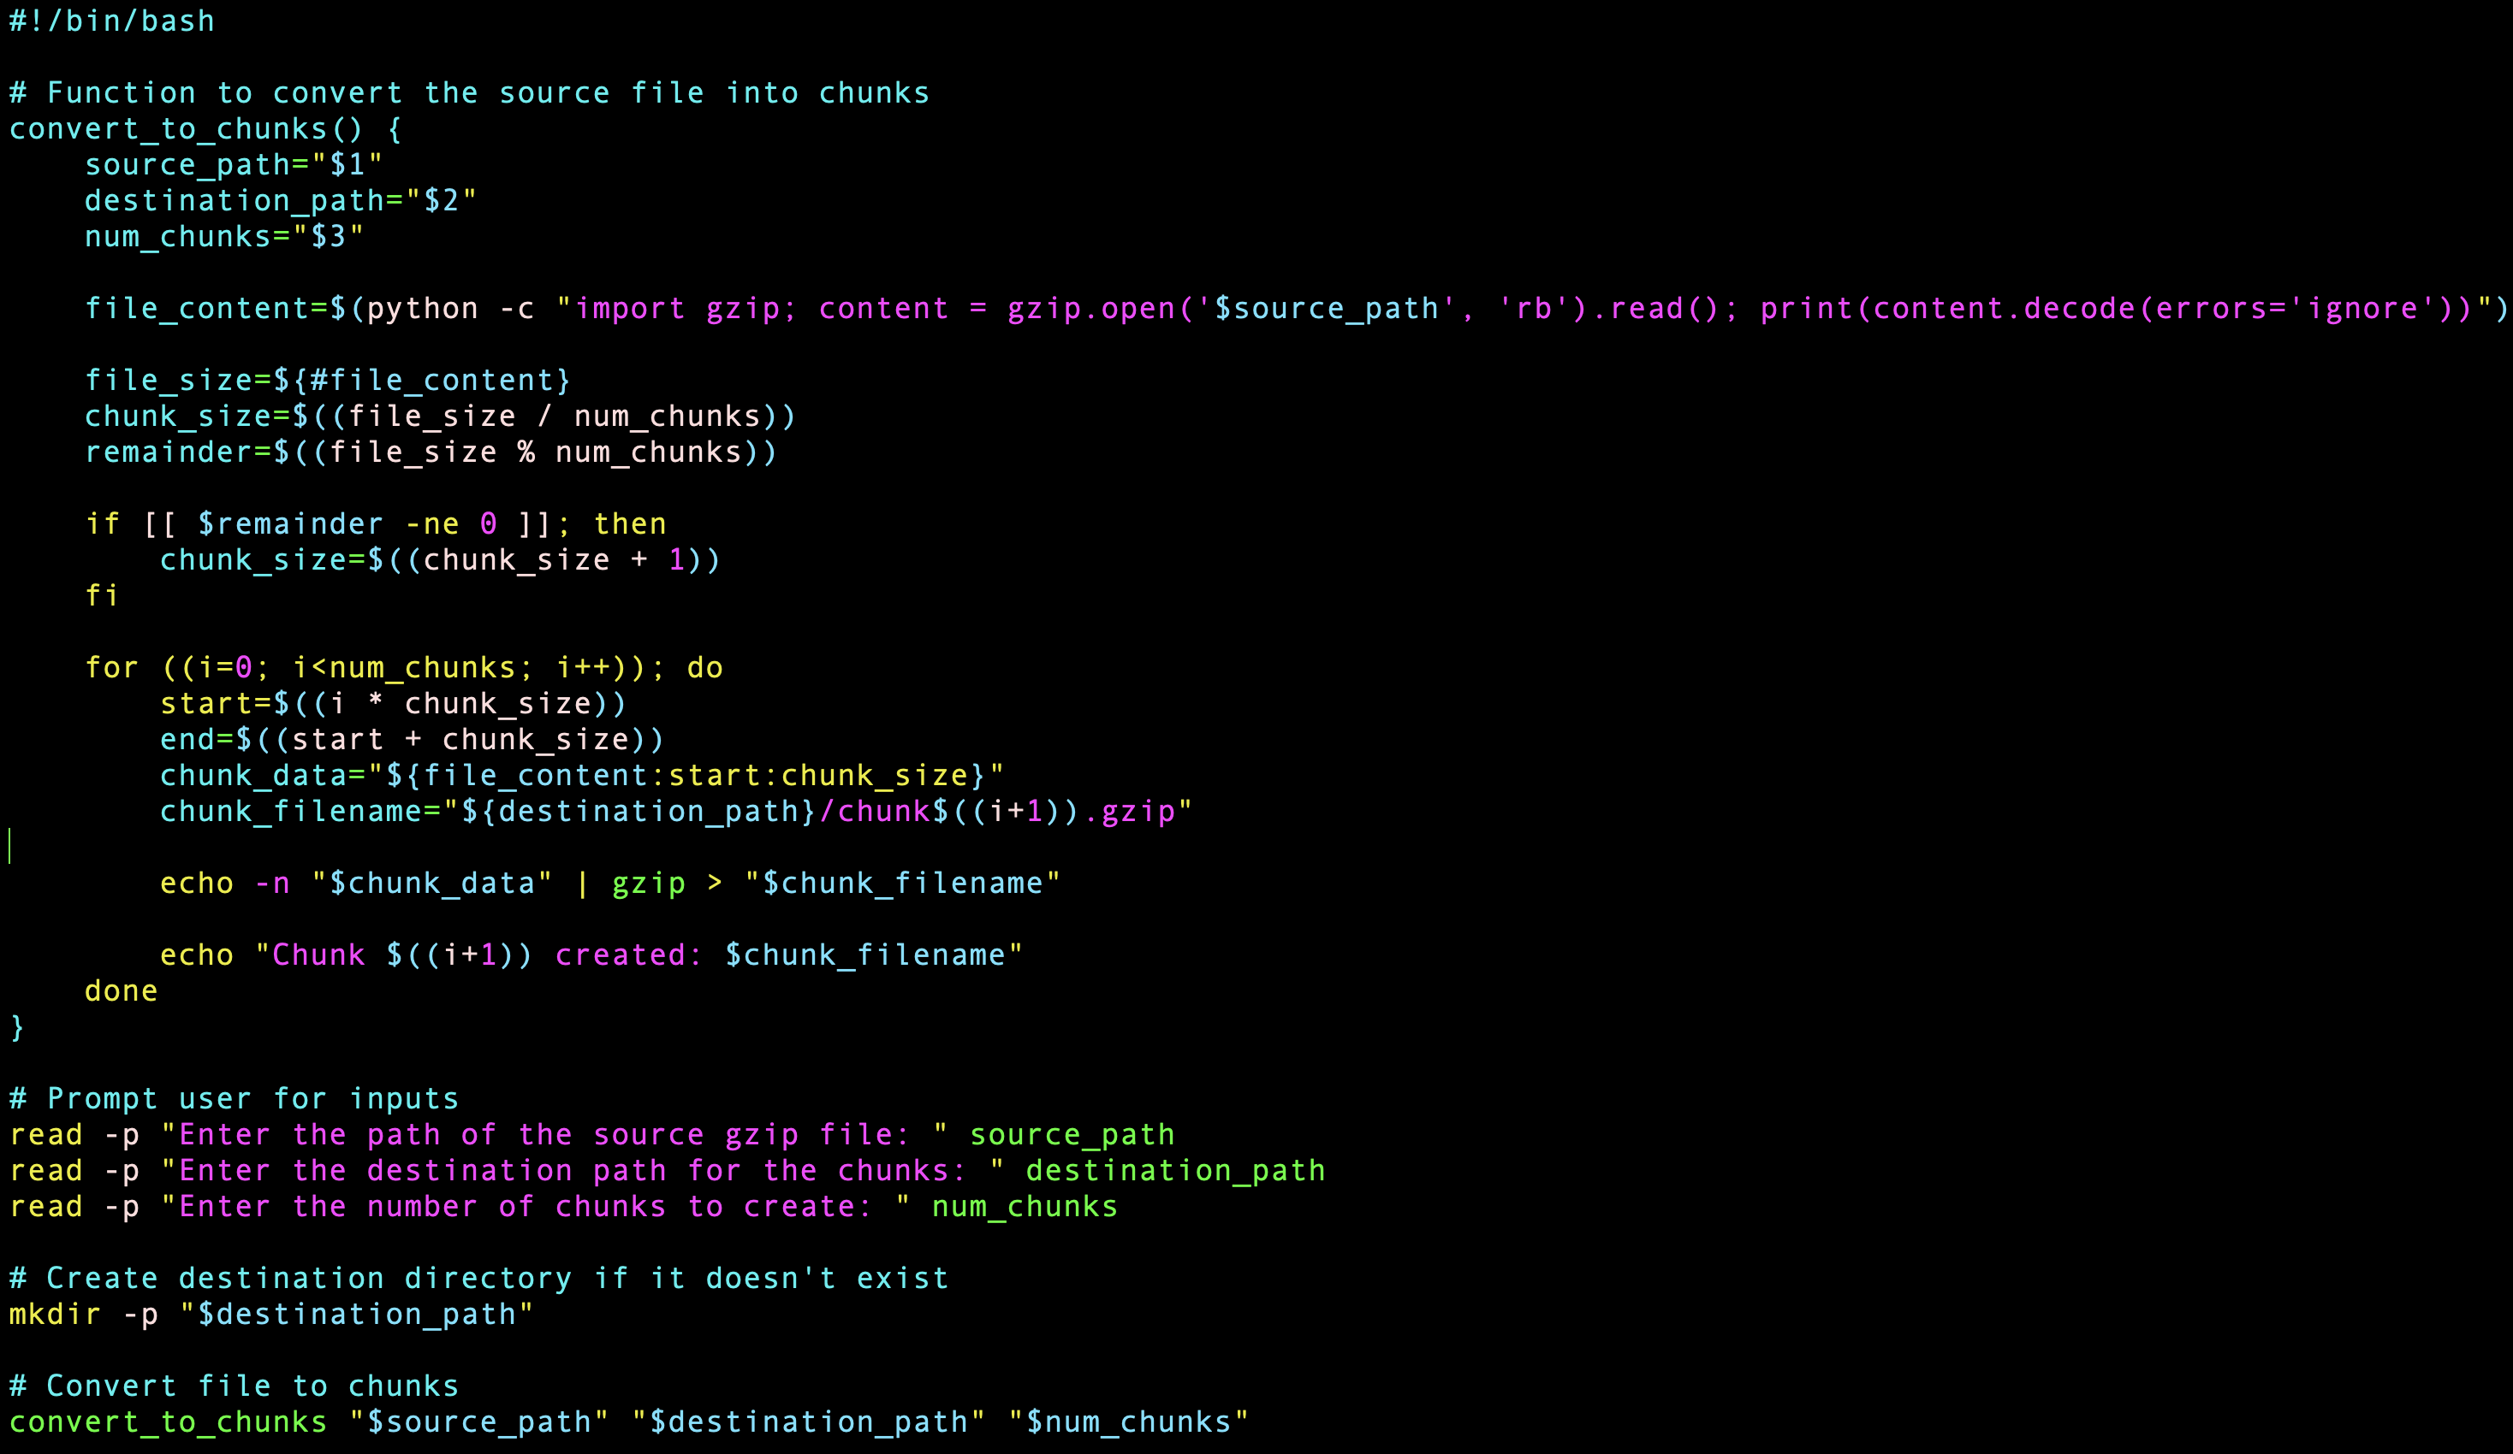

## Write any script file to merge to merge all the chunks into a gzip file

1.Once you run the script file all the chunks should be merged as a single gzip file

Script to merge the files

